**2024F FIN 4104 1 [Online 5] Investments II**

**Online Assignment 1**

**Assignment #1 – Group #5**

**SYED ADNAN C0908413**

**HARSHDEEP SINGH C0904869**

**JANKI THAKKAR C0904860**

**MEHAK SAINI C0913094**

**YASH AGGARWAL C0904878**

1. **COMMUNICATION SERVICES:**

**1832 ASSET MANAGEMENT L.P. SCOTIA NASDAQ INDEX FUND - SERIES A**

Objectives:

* High Growth Potential: depends on the major, big U.S. technology companies to deliver higher returns.
* Long-Term Investment: Suitable for individuals who invest for a long time.
* High risk: it means the value will go up or down a lot, and because of that, you lose money.
* No Guarantees: There's no assurance that you will get back your investment.
* For Risk-Takers: Perfect if you're okay with taking the risk for a possible higher reward.

1. **CONSUMER DISCRETIONERY:**

**1832 ASSET MANAGEMENT L.P. SCOTIA U.S. EQUITY INDEX FUND - SERIES A**

Objectives:

* US Market Growth: Mixes investments to track a major U.S. stock market index, targeting leading companies.
* Long-term growth: This is designed for the investor looking for long-term capital appreciation.
* Low-Cost Investment: No sales charges. Low management fee of 1.06%.
* Diversification: Exposure to the U.S. domestic market in one portfolio without worries of stock selection.
* Strong Historical Returns: It has realized an average annual return of 13.3% in the past decade.

1. **CONSUMER STAPLES:**

**1832 ASSET MANAGEMENT L.P. SCOTIA INTERNATIONAL EQUITY INDEX FUND - SERIES A**

Objectives:

* High Return Possibility: A chance to return by investing in a variety of international companies.
* Low Fees: The management fee is still on the low side at 1.17%, which implies more of your money remains invested.
* Risk Tolerance: Suitable for investors comfortable with market ups and downs; looking for growth, not steady income.
* Past Performance: In the past, it has returned reasonably well, averaging 5.1% annually over the last ten years.
* Easy management: You are not required to pick individual stocks. The fund does this automatically for you, having regard to some well-known market index.

1. **ENERGY:**

**1832 ASSET MANAGEMENT L.P. SCOTIA RESOURCE FUND - SERIES A**

Objectives:

* Natural Resources Focus: Invests primarily in oil, gas, and mining firms.
* Long-Term Growth: Looks to achieve growth over a longer period of time, even with fluctuations in the market.
* Higher Risk Potential: Higher return but with a higher level of risk.
* No Sales Fees: Contribute or sell shares without extra costs.
* Diversified Investment: The risk is decreased due to the distribution of investment among different resource companies.

1. **FINANCIALS:**

**1832 ASSET MANAGEMENT L.P. SCOTIA CANADIAN BALANCED FUND - SERIES A**

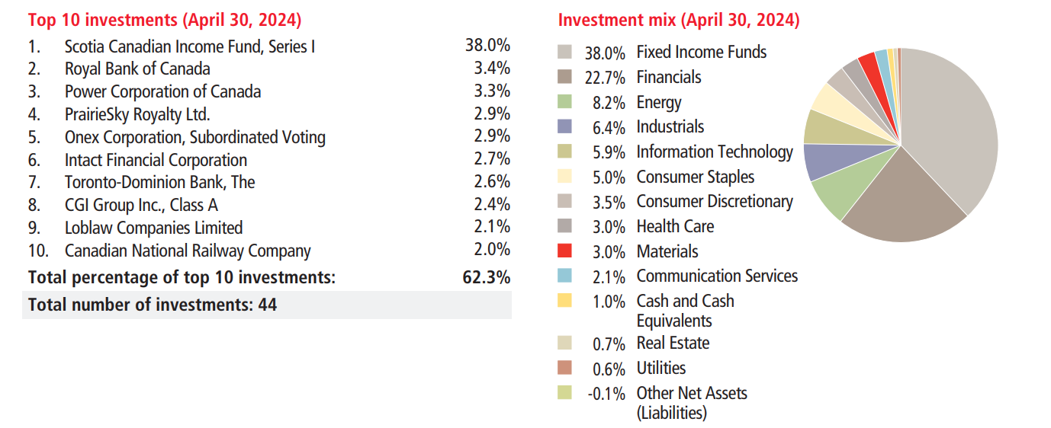

Objectives:

* Growth and Income: This implies that your money grows while giving some current income.
* Diversified Investments: Your money will be distributed among different kinds of investments to reduce risks.
* Long-Term Focus: It is targeted at persons whose aim is to invest in this for several years and not for quick cash.
* Market Fluctuations: One should consider that the value of such an investment will fluctuate over time.
* No Extra Fees: One can buy or sell any amount of shares without the payment of extra sales charges.

1. **HEALTHCARE:**

**1832 ASSET MANAGEMENT L.P. SCOTIA U.S. OPPORTUNITIES FUND - SERIES A**

Objectives:

* Growth Potential: The annual return is targeted at about 8.5%, founded on the past ten-year performance.
* Diversification: Your investment will be diversified among a pool of large companies in the United States, meaning lesser risk due to dependence on just one stock or sector.
* Long-Term Focus: Best for investors who can keep their investment for at least 5-10 years to capture market growth.
* Flexible Investment: Avail the benefit of no-load units, with no extra charges for the purchase and sale or switching of units of funds.
* Risk Understanding: Note well that the risk grade of the fund is medium to high, with substantial possibilities of gain and substantial possibilities of loss.

1. **INDUSTRIALS:**

**1832 ASSET MANAGEMENT L.P. SCOTIA INTERNATIONAL EQUITY INDEX FUND - SERIES A**

Objectives:

* Grow Your Money: The fund has invested in the growth of your money, targeting large companies from other countries and realizing an average annual return of about 5.1% for the last 10 years.
* Lower Risk: The fund assists in reducing the risk of losing money, subject to diversification, since it invests in a variety of companies instead of investing all your money in just a few companies.
* Long-term Investment: This fund can be suitable for investors who have at least a period of 5 years to provide good returns.
* Be prepared to handle ups and downs in the stock market: Such an investment would be suitable for those who could handle the ups and downs in the stock market.
* Low Management Costs: It takes around 1.17% annually to manage the fund, which means if you invest $1,000, around $11.70 goes toward keeping the fund running.
* **Information Technology:**

**1832 Asset Management L.P. Scotia Canadian Growth Fund - Series A**

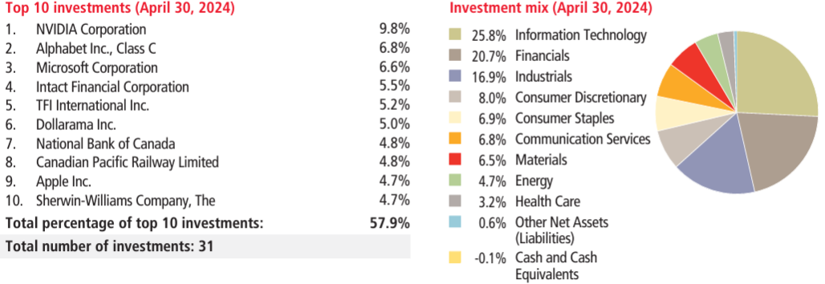

**Objectives:** The key objectives for this fund are:

* Risk Level (Medium): The overall value of the fund can increase as well as decrease. It is rated as a medium risk investment, meaning a balance between possible gains and losses.
* Volatility Fluctuating Returns: Returns may vary over time. The fund best 3-month return was 16.8% biggest gain and the worst 3-month return was -15.7% biggest loss. Over the last 10 years on average, this fund earned 7.6 % per year.
* Long-Term Growth: You need to be ready to keep the money in this fund for a long period of time- over several years-if you are to get good growth from it. It would not be the ideal fund if any constituent needs regular income, at least anytime soon.
* Costs (2.11% Annual Fees): This translates into approximately 2.11% of your investment, which is collected as management and other fees at the end of every year on acquisition of shares. For every $1,000 investment, one would anticipate bearing the cost of approximately $21.10 annually on fees that eat into their returns.
* It is suitable for people who have no issues with the ups and downs in the stock market and are expecting returns on investment over longer terms
* **Real Estate 1832 Asset Management L.P. Scotia Mortgage Income Fund - Series A**

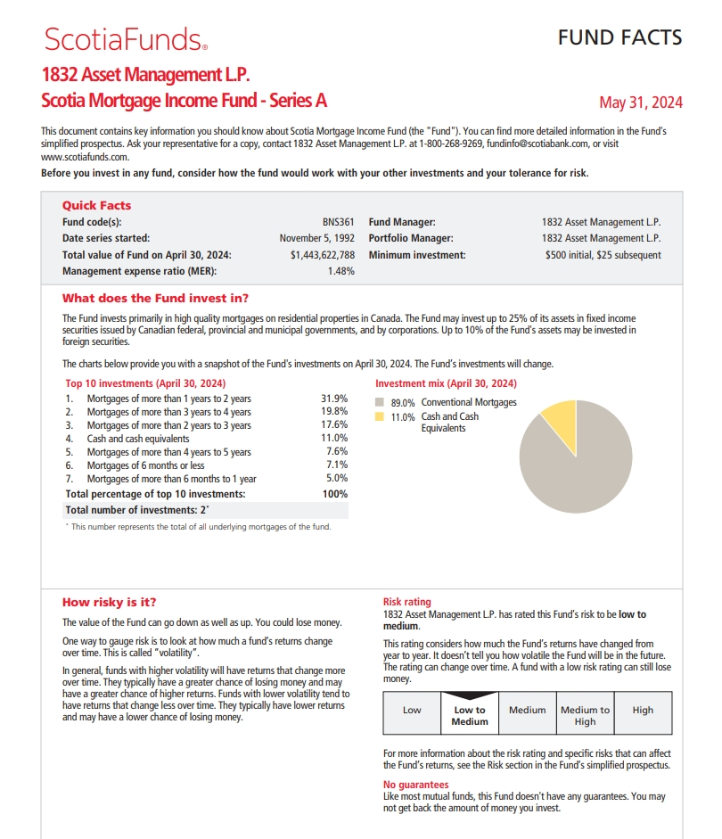

**Objective:** The objective for this fund is:

* Earn regular income: Since the fund invests mainly in mortgages, which in turn pay interest on a regular basis, you would expect some modest income on a regular basis.
* Preserve capital with lower risk: The fund comprises 89% of conventional mortgages, considered some of the safest investments. It also has 11% in cash or its equivalent, lowering risks further.
* Moderate Risk: The investment carries a low to medium level of risk. It is, therefore, more stable compared to highly risky investments like stocks, though there is still a partial possibility of losing your money.
* Invest in mortgages: You'd be primarily invested in residential mortgages but have some room-25%-for government or corporate bonds, and as much as 10% in foreign securities, although the greatest chunk of the fund remains invested in Canadian assets.
* Earn modest returns: Over 10 years the average annual return is 1.4% and if we had invested $1000 in 10 years then it would be valued around approximately $1,153. It means that you will not suffer big losses.
* **Materials:**

**1832 Asset Management L.P. Scotia Resource Fund - Series A**

**Objectives**

* Capital Growth: Over a ten-year period, the annualized return has been around 7.3%, which helps the fund aims to increase the value of your investment in the long term. This suits those who want to see the value of their investment grow over the years.
* Sector-Specific Exposure: Most of the focus is infrastructural and energy oriented (>67.5) and non-infrastructural but rather materials, oil, gas, metals, and mining (>32.1) rendering core sourcing of revenue from these industries that embrace derived resources. Up to 49% of its assets can be invested in foreign securities, improving diversification.
* A Medley of High Risk and High Potential Returns: It’s a high risk fund, thus with high volatility – its best 3-month return was +39.5%, the lowest being -31.5% at its worst. Appropriate for risk-tolerant investors who are willing to take a chance with the short-term market.
* Long-Term Investment Horizon: The best investment horizon for the fund is in the range of 5 – 10+ years or the time frame required to fully recover from losses.
* Manageable Costs: The fund has a 2.09% MER which means expenditure will be incurred and returns will be lower than otherwise if this was not the case. For those trade too often (30 days or less) there is a 1% fee to discourage such practice.
* **Utilities:**

**1832 Asset Management L.P. Scotia Canadian Dividend Class - Series A**

**Objectives**

* Capital Growth & Dividends: Involves investing in Canadian stocks with a long term prospect of paying dividends.
* Diversified Exposure: Active management focuses on the financials sector 31.2% with a fair amount of energy, industrials and it.
* Moderate Risk: Risk Level is appropriate for investors who can tolerate a moderate level of movements in the share market.
* Long-Term Investment: Best suited for a time frame of 5-10+ years, not for people looking out for stable monthly returns.
* Reasonable fees: Charging a 1.79% MER on Management Expense Ratio followed by 1% fee on trades made within the 30 days.
* Tax Planning: This is efficient in non registered accounts; do not ignore taxes on distribution.

**References:** Scotiabank. (2024). *All mutual funds: Domestic, international & specialty funds*. ScotiaFunds. <https://www.scotiafunds.com/en/home/all-funds.html>